**Overdale Reading Skills Progression**

**Reception**

**Autumn 1**

• Use wordless books to establish book behaviours, book talk and to grow vocabulary with small groups of children.

• Ensure all children who are not yet blending get additional blending practice in this session.

• From week 3 or 4 onwards, some children in Reception will be ready to practise reading books before the first assessment. Do not hold them back. Children who are blending confidently can read books with the graphemes s a t p i n m d, but with no tricky words.

• Children who are not blending by week 3 need 10 minutes of additional blending practice every day – see the ‘Individual and group keep-up teacher’s guide’ for Reception.

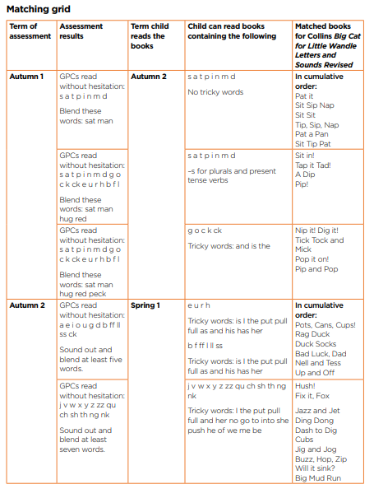

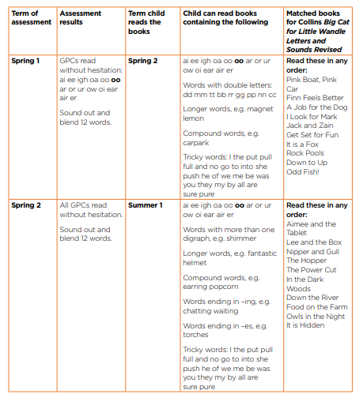

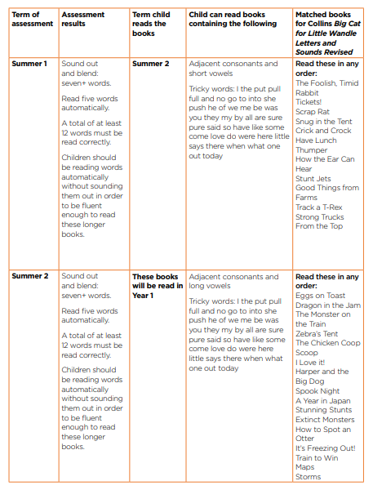

**Year 1**

**Autumn 1**

. • Use the books identified by the Reception Summer 2 assessment. Most children will be reading books with Phase 4 words, either adjacent consonants and short vowels or adjacent consonants and long vowels.

• Do not use books with Phase 5 GPCs this term as they have not yet been taught. The books the children are reading should increase their reading stamina and fluency, ensuring that they are confident and ready to read books with the Phase 5 GPCs they have learned in Autumn 2.

